Given a pointer to the root of a binary tree, you need to print the level order traversal of this tree. In level-order traversal, nodes are visited level by level from left to right. Complete the function ***levelOrder*** and print the values in a single line separated by space.

For the above tree, the level order traversal is 1 -> 2 -> 5 -> 3 -> 6 -> 4.

**Input Format**

You are given a function,

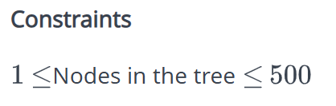

**Output Format**

Print the values in a single line separated by a space.

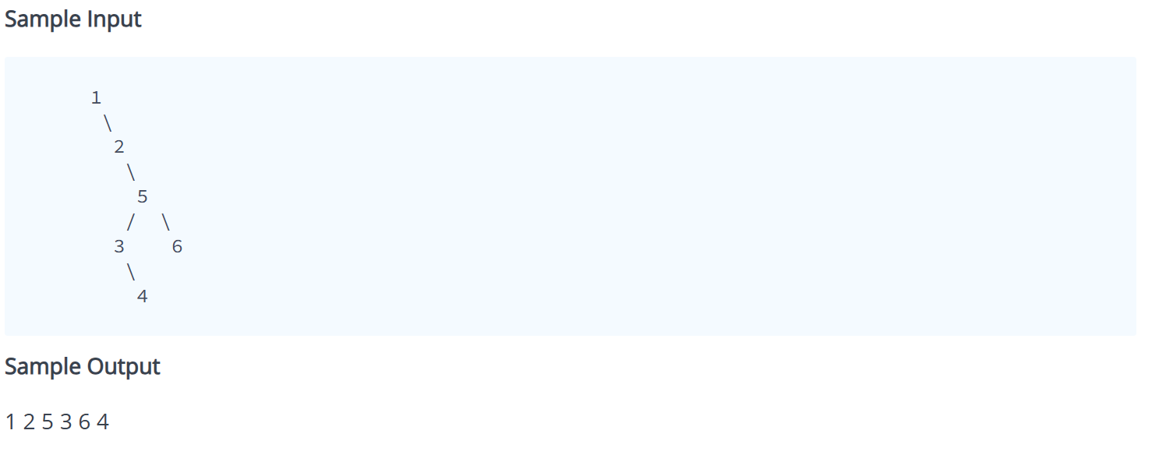

**Explanation**

We need to print the nodes level by level. We process each level from left to right.  
Level Order Traversal: 1 -> 2 -> 5 -> 3 -> 6 -> 4.